MODULE 1 – Getting to know the environment

Navigation:

Use the arrow keys to navigate. Select using Enter and cancel using Esc keys.

Change the directories:

ALT+O > Directories > Include Directories: <location of include folder in the TurboC folder>

ALT+O > Directories > Library Directories: <location of library folder in the TurboC folder>

ALT+O > Directories > Output Directory: <location of output folder in the TurboC folder>

ALT+O > Directories > Turbo C Directory: <location of TurboC folder>

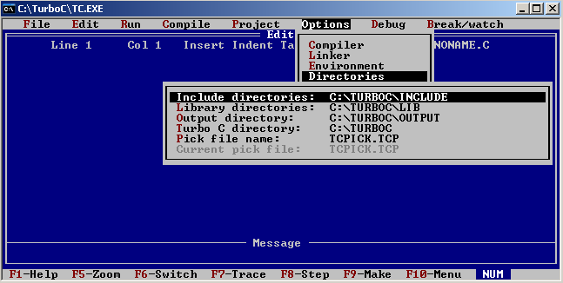

Explore the TurboC environment using the ALT and CTRL + commands.

Empty Project Name

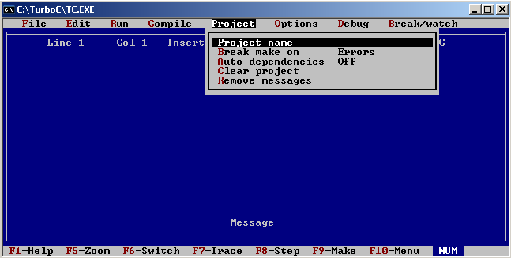

Feel free to look around the environment

Next: MODULE 2 - Print